# Instructions for running rjags on HPC

Similar to HPC instructions from the [wiki page](https://wiki.qut.edu.au/display/hpcqut/Installing+and+managing+your+own+R+packages+-+HPC+System), these instructions are amended to install the rjags package (rjags_3-15) and make it run with JAGS version which is already installed in Lyra (jags/3.4.0).

These instructions are not for the latest version of JAGS and rjags package[1]. Linux code snippet to enter in terminal is in ‘blue’font.

To begin:

1. Remote connect to Lyra, and go to the desired working directory.
2. The rjags package which is compatible with JAGS version 4-6 (which is already installed in Lyra), is rjags 3-15. Download the rjags_3-15.tar.gz file from [here](https://sourceforge.net/projects/mcmc-jags/files/rjags/3/) and move it to your working directory.
3. Decompress the package with command ‘tar –xzvf rjags_3-15.tar.gz’. You will see something like this:

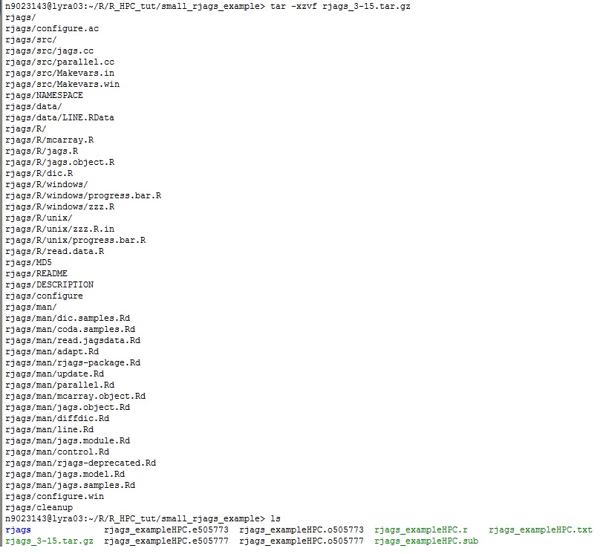

1. Create folder on home directory for storing the R library ‘mkdir ~/my-R-libs/’. Move the rjags folder only (shown in blue in the figure above) onto your new R library directory.
2. Load the R and JAGS module in your working directory with ‘module load R/3.0.3_gcc’ and then ‘module load jags’ (it will automatically load jags/3.4.0).
3. Install rjags with command ‘R CMD INSTALL rjags –l ~/my-R-libs/’. You should see the following:

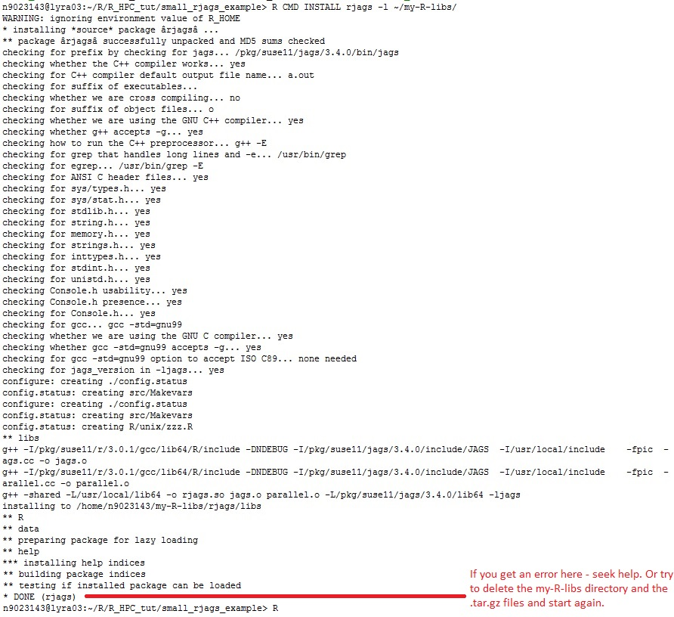

1. Create an R environment file, so that R knowns where to look for your personalised library,

‘echo ‘R_LIBS_USER=”~/my-R-libs”’ > ~/.Renviron’

1. On the shell terminal start R, by typing ‘R’ and in the command prompt, see the last line of the code above. Type ‘library(rjags)’ to check that it A) R package rjags can talk to JAGS software and B) the rjags package can be loaded onto the workspace.

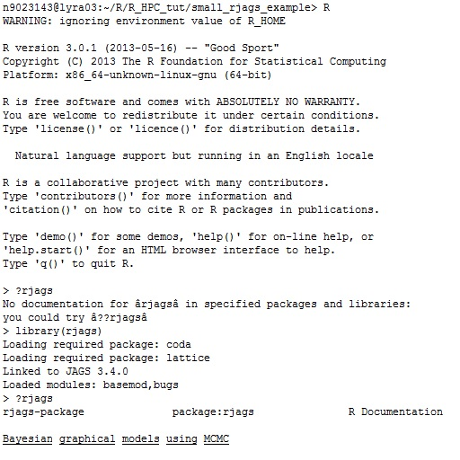

1. Quit R with ‘q()’ and then choose ‘n’ to not save your workspace.

You now have rjags installed!

Remember in your r-scripts to include ‘library(rjags)’command.

**\*\*\* optional \*\*\*** Unzip and run example in small_rjags_example.zip file to test correct working of rjags. This .zip file also contains examples of error outputs, and example R file to store model diagnostics and output.

1. I downloaded the latest version of JAGS (JAGS-4.2.0) and rjags package (rjags 4-6, both files found [here](https://sourceforge.net/projects/mcmc-jags/files/)) and while I could unpack both tar balls in Lyra, I had difficulty making the R installation of the rjags package see the latest JAGS software, either by the R CMD INSTALL commands or by the install.packages() in the R terminal. If anyone knows how to run the correct command to do this, please let me know!